AFLogical OSE

**Aim:**

To extract logical data such as contacts, messages, and call logs from an

Android device using AFLogical OSE tool.

**DESCRIPTION ABOUT THE TOOL USED:**

AFLogical OSE (Open Source Edition) is a mobile forensic tool that extracts logical data from Android devices. It gathers user information such as call logs, messages, and contacts into readable formats. The extracted data can then be imported into Autopsy for further examination. AFLogical is non-invasive and maintains device integrity during acquisition. It is highly useful in investigations involving smartphones. This experiment demonstrates the importance of mobile data in modern forensic analysis.

**STEPS INVOLVED:**

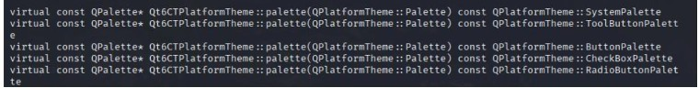



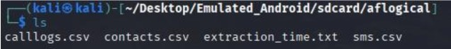

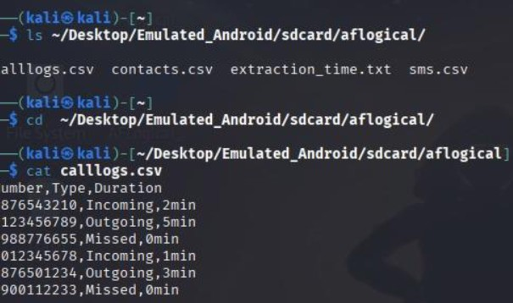

**RESULT:**

